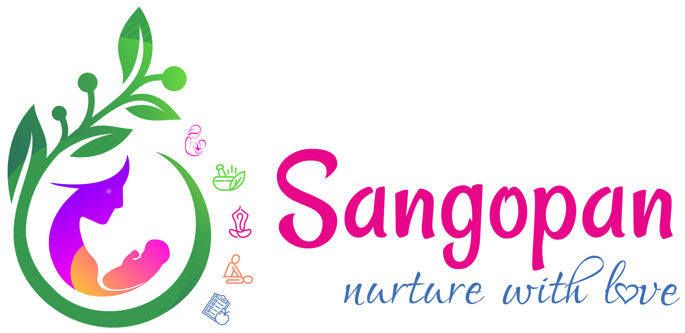
Diet Consultation Form

Name of the Mother
Height
Weight
☐ Dinner
Regular Food timings
Do you any Food Allergies? | ☐ Salty  ☐ Sour  ☐ Sweet  ☐ Breakfast  ☐ Snacks  ☐ Lunch
Tastes liked most: | ☐ Salty  ☐ Sour  ☐ Sweet
Most Favourite Food- (Eg:Like Ice cream, Pani Puri, Chaat,Oily fatty Cheese, Paneer)
Rate your digestion | ☐ Fair  ☐ Poor  ☐ Describe your appetite  ☐ Good
Quantity of water consumed in a day? (In Ltrs)
Rate your water consumption | ☐ Moderate  ☐ Less  ☐ Excess
Specific Eating habits:
Which is your main meal? | ☐ Lunch  ☐ Dinner  ☐ Breakfast
Are you? | ☐ Non-Vegetarian  ☐ Vegan  ☐ Vegetarian
Def Non-vegetarian please specify | ☐ Any other  ☐ Chicken  ☐ Fish  ☐ Beef  ☐ Pork  ☐ Meat
If Non-Vegetarian the frequency of consumption of Non-Veg
If Vegan: From how many years?
Fruits: Name the fruits you eat commonly and its frequency | Quantity
Milk Habits: Which Milk | ☐ Buffalo Milk  ☐ Soy Milk  ☐ Cow Milk  ☐ Whole Milk
Frequency of eating outside food
Frequency of eating junk food and oily food | ☐ Which juices  ☐ Quantity at a time  ☐ Frequency
Dp you consume packed juices/Milkshakes
Do you consume Diet Coke? | ☐ Which type  ☐ Quantity at a time  ☐ Frequency
Frequency of Drinking Soda/ Soft drinks
Alcohol Consumption | ☐ Salty  ☐ Sour  ☐ Sweet
Frequency of eating late night in week?
Frequency of eating sweets or deserts in week?
Do you have habit of eating in between the meals?
Describe your eating? | ☐ Moderate  ☐ Less  ☐ Excess
Bowel Habits | ☐ Constipated  ☐ Regular
No
If Yes, Pls sepcify
Yes

